- Create a customized Docker image using a Dockerfile.
1. Created ec2 having t2.madium with Amz Linux.
2. Installed and started docker
yum install docker -y
sudo systemctl start docker
sudo systemctl enable docker
3. sudo usermod -aG docker $USER
1. Clone the source repo (Python app)
git clone https://github.com/betawins/Python-app.git
cd Python-app
2. Check what files exist
● Look for a requirements.txt (Python dependencies)
● Look for a main script (app.py, main.py, or similar)
3. Write a Dockerfile (generic version for now)
Create a file called Dockerfile in the repo folder:
# Use lightweight Python base image
FROM python:3.11-slim
# Set working directory
WORKDIR /app
# Copy requirements first and install dependencies
COPY requirements.txt ./
RUN pip install --no-cache-dir -r requirements.txt
# Copy the rest of the code
COPY . .
# Expose the app port (assuming Flask default)
EXPOSE 5000
# Start the app (adjust if entry file is different)
CMD ["python", "app.py"]
4. Build the Docker image
From inside the repo folder:
docker build -t python-app:latest .
5. Run the container to test
docker run -d -p 8080:8080 --name python-test python-app:latest
Open browser → http://localhost:8080
(Or EC2 public IP if running on a VM).
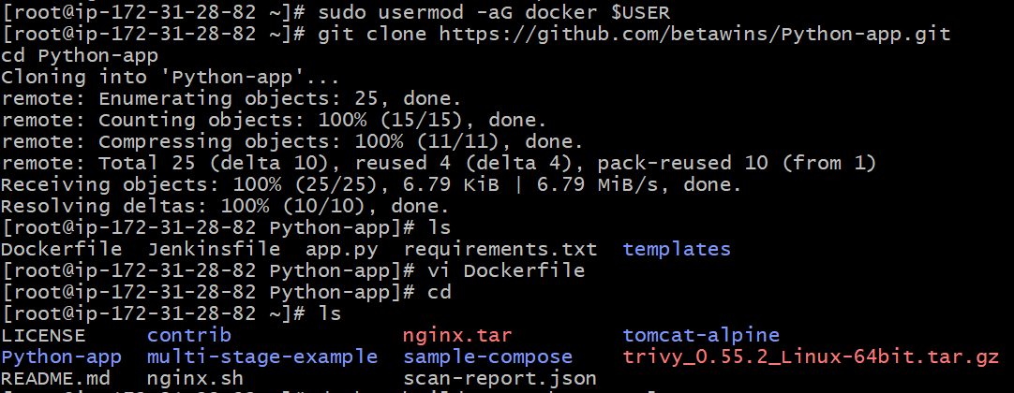
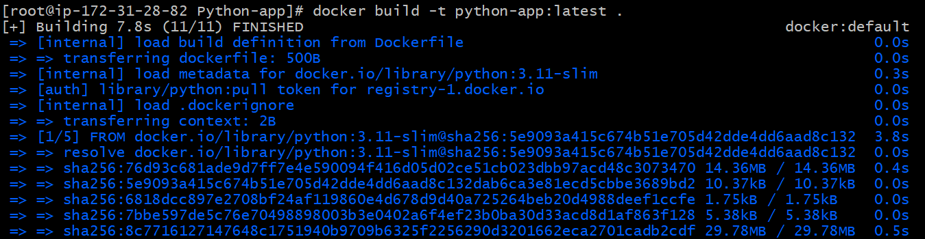
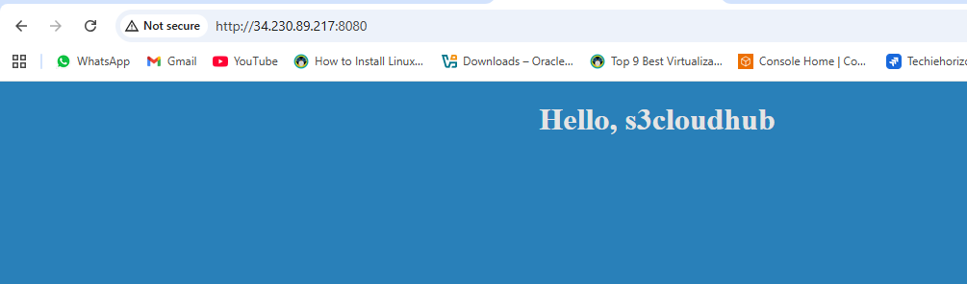
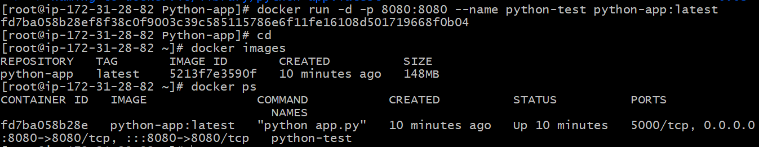
- Push the image to Docker Hub.
1. Create a Docker Hub account (if not already)
https://hub.docker.com
Create a repo there, e.g. python-app.
2. Log in to Docker Hub from EC2
docker login
It will ask for:
● Username → your Docker Hub username
● Password → your Docker Hub password or access token
3. Tag your image with Docker Hub repo name
Replace your-username with your actual Docker Hub username:
docker tag python-app:latest your-username/python-app:latest
4. Push to Docker Hub
docker push your-username/python-app:latest
5. Verify
Go to your Docker Hub repo in browser → you should see python-app:latest image uploaded.
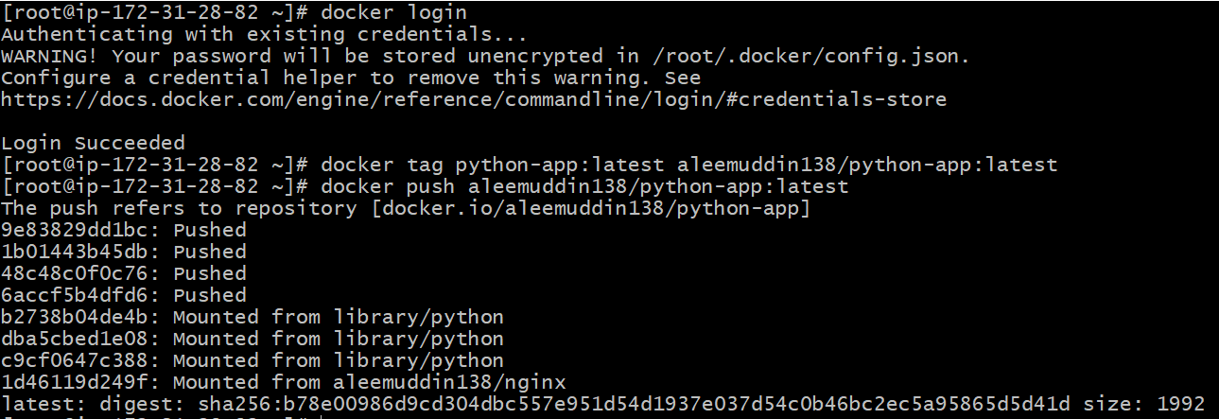
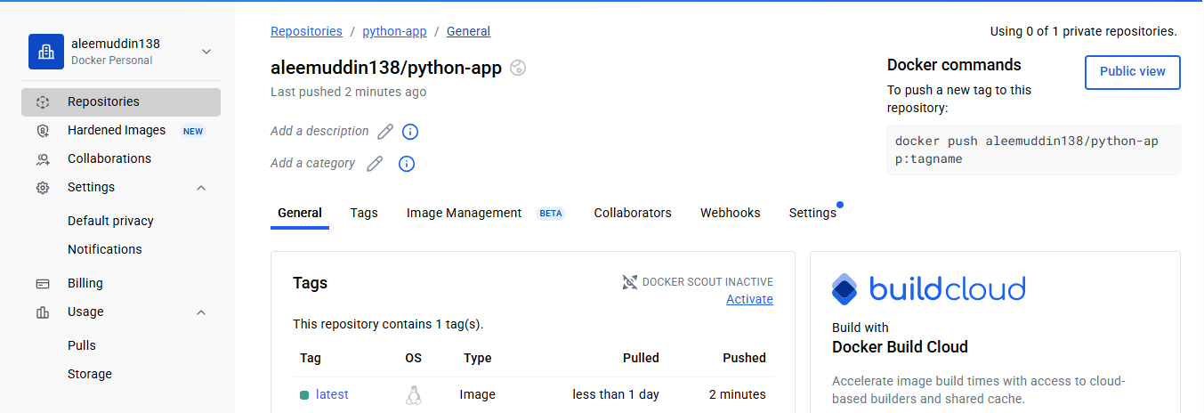
- Push the same image to Amazon ECR.
1. Pre-requisites
● AWS CLI installed on your EC2 (usually already there on Amazon Linux).
● Your AWS CLI configured with credentials:
aws configure
Enter AWS Access Key, Secret, region (e.g. us-east-1), and output format (json).
2. Create an ECR repository
Replace python-app with your app name:
aws ecr create-repository --repository-name python-app --region us-east-1
If repo already exists, you’ll get a message — that’s fine.
3. Authenticate Docker to ECR
aws ecr get-login-password --region us-east-1 | docker login --username AWS --password-stdin <AWS_ACCOUNT_ID>.dkr.ecr.us-east-1.amazonaws.com
👉 To get your AWS account ID:
aws sts get-caller-identity --query Account --output text
4. Tag your Docker image for ECR
docker tag python-app:latest <AWS_ACCOUNT_ID>.dkr.ecr.us-east-1.amazonaws.com/python-app:latest
5. Push image to ECR
docker push <AWS_ACCOUNT_ID>.dkr.ecr.us-east-1.amazonaws.com/python-app:latest
6. Verify
Go to AWS Console → ECR → Repositories → python-app
You should see your image there.
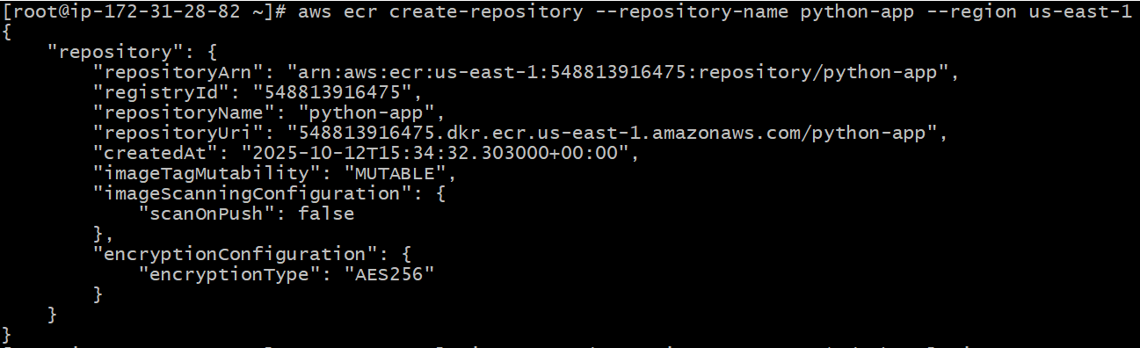
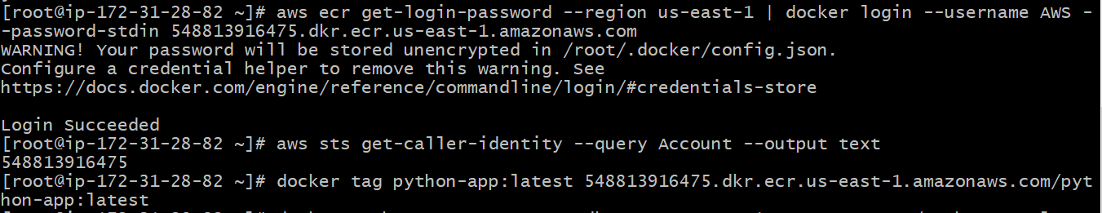
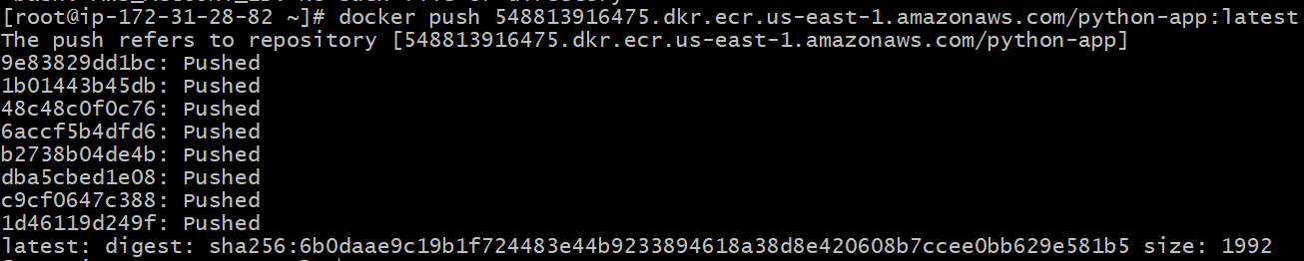
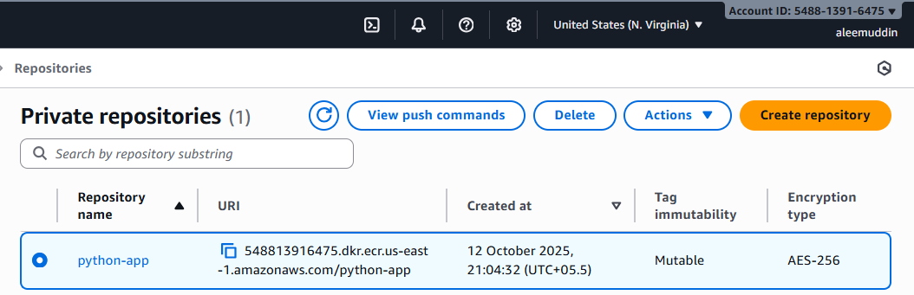
- Provision one EC2 instance using Terraform and install Jenkins.
✅ Install Terraform on Host (Recommended for Beginners)
● Simple: sudo yum install -y yum-utils or sudo apt-get install unzip → then download Terraform binary.
● Easier to manage AWS CLI + credentials (Terraform will read from ~/.aws/credentials).
● Better if you’re just starting with Terraform + AWS.

sudo yum install -y yum-utils
sudo yum-config-manager --add-repo https://rpm.releases.hashicorp.com/AmazonLinux/hashicorp.repo
sudo yum -y install terraform
We’ll write Terraform code to:
● Create a key pair (so you can SSH if needed).
● Create a security group (open SSH 22 + Jenkins 8080).
● Launch an EC2 instance with Jenkins installed automatically via user_data.
1. Create a Terraform folder
mkdir terraform-jenkins && cd terraform-jenkins
2. main.tf:
variable "ami" {}
variable "region" {}
variable "public_ip" {}
provider "aws" {
region = "us-east-1"
}
# EC2 Security Group - Allow SSH (22), Jenkins (8080), HTTP (80)
resource "aws_security_group" "jenkins_sg" {
name = "jenkins-sg"
description = "Allow SSH, HTTP and Jenkins port"
vpc_id = aws_vpc.main.id
ingress {
description = "SSH"
from_port = 22
to_port = 22
protocol = "tcp"
cidr_blocks = ["0.0.0.0/0"]
}
ingress {
description = "Jenkins"
from_port = 8080
to_port = 8080
protocol = "tcp"
cidr_blocks = ["0.0.0.0/0"]
}
ingress {
description = "HTTP"
from_port = 80
to_port = 80
protocol = "tcp"
cidr_blocks = ["0.0.0.0/0"]
}
egress {
description = "All traffic out"
from_port = 0
to_port = 0
protocol = "-1"
cidr_blocks = ["0.0.0.0/0"]
}
}
# VPC
resource "aws_vpc" "main" {
cidr_block = "10.0.0.0/16"
enable_dns_hostnames = true
enable_dns_support = true
tags = { Name = "jenkins-vpc" }
}
# Subnet
resource "aws_subnet" "public" {
vpc_id = aws_vpc.main.id
cidr_block = "10.0.1.0/24"
availability_zone = "us-east-1a"
map_public_ip_on_launch = true
tags = { Name = "jenkins-subnet" }
}
# Internet Gateway
resource "aws_internet_gateway" "igw" {
vpc_id = aws_vpc.main.id
tags = { Name = "jenkins-igw" }
}
# Route Table
resource "aws_route_table" "rt" {
vpc_id = aws_vpc.main.id
route {
cidr_block = "0.0.0.0/0"
gateway_id = aws_internet_gateway.igw.id
}
tags = { Name = "jenkins-rt" }
}
resource "aws_route_table_association" "rta" {
subnet_id = aws_subnet.public.id
route_table_id = aws_route_table.rt.id
}
# EC2 Instance with Jenkins install
resource "aws_instance" "jenkins" {
ami = "ami-0886832e6b5c3b9e2" # Amazon Linux 2
instance_type = "t2.medium"
subnet_id = aws_subnet.public.id
vpc_security_group_ids = [aws_security_group.jenkins_sg.id]
key_name = "first_server1" # <-- change to your key
associate_public_ip_address = true
user_data = <<-EOF
#!/bin/bash
set -e
yum update -y
yum install -y wget
yum install -y git
dnf install -y java-17-amazon-corretto
wget -O /etc/yum.repos.d/jenkins.repo \
https://pkg.jenkins.io/redhat/jenkins.repo
rpm --import https://pkg.jenkins.io/redhat/jenkins.io-2023.key
yum upgrade -y
yum install -y jenkins
systemctl enable jenkins
systemctl start jenkins
EOF
tags = { Name = "jenkins-server" }
}
output "jenkins_public_ip" {
value = aws_instance.jenkins.public_ip
}
3. Run Terraform
terraform init
terraform apply -var "ami_id= ami-0886832e6b5c3b9e2" -var "key_name=Virginia" -var "my_ip= 34.230.89.217"
If Required.
👉 Replace ami-xxxxxxxx with a valid Ubuntu 22.04 AMI ID for your AWS region.
👉 Replace your-keypair with your existing AWS EC2 key pair.
👉 Replace YOUR_IP/32 with your actual public IP (from curl ifconfig.me).
4. Access Jenkins
● After apply, Terraform will show jenkins_url like:
http://<EC2-Public-IP>:8080
● Open that in your browser.
● First-time setup → Jenkins asks for initial admin password:
sudo cat /var/lib/jenkins/secrets/initialAdminPassword
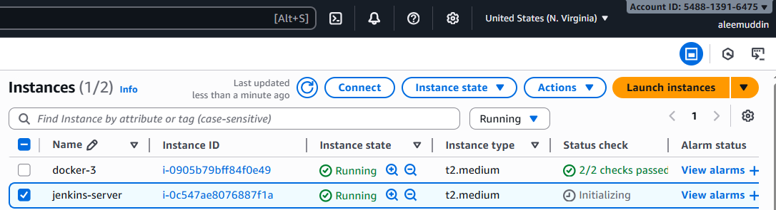
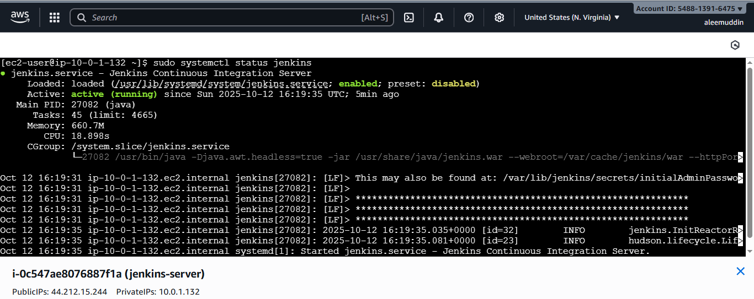
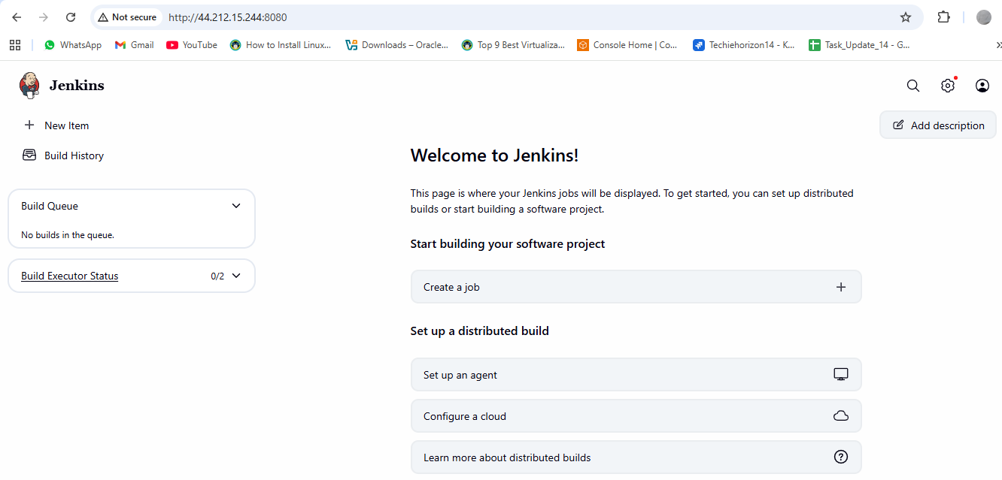

- Create one Jenkins job to build and push the Docker image to Docker Hub.
  - Source: https://github.com/ALEEMUDDIN138/Python-app.git'
Now that Jenkins is installed (from Task 4), and install docker also and we’ll set up a job (pipeline) that:
1. Pulls the source code from GitHub (https://github.com/betawins/Python-app.git)
2. Builds the Docker image
3. Pushes it to Docker Hub
✅ Step 1: Prepare Jenkins
1. Login to Jenkins: http://<EC2-Public-IP>:8080
2. Unlock Jenkins with the password:
sudo cat /var/lib/jenkins/secrets/initialAdminPassword
3. Install suggested plugins.
4. Create your Admin User.
✅ Step 2: Install required Jenkins plugins
● Go to Manage Jenkins → Plugins → Available Plugins
● Install:
○ Docker Pipeline
○ Pipeline
________________________________________
✅ Step 3: Add Docker Hub credentials in Jenkins
1. Go to Manage Jenkins → Credentials → System → Global credentials
2. Add new credential:
○ Kind: Username with password
○ ID: dockerhub (we’ll use this in pipeline)
○ Username: your Docker Hub username
○ Password: your Docker Hub password
________________________________________
✅ Step 4: Create Jenkins Pipeline Job
1. Click New Item → enter name Build-and-Push-Python-App
2. Select Pipeline → OK.
3. Scroll down to Pipeline script and paste this Jenkinsfile:
Dockerfile:
FROM python:3.6
RUN pip install flask
COPY . /opt/
EXPOSE 8080
WORKDIR /opt
ENTRYPOINT ["python", "app.py"]
Jenkinsfile:
pipeline {
agent any
environment {
DOCKERHUB_CREDENTIALS = credentials('python-app')
IMAGE_NAME = "aleemuddin138/python-app"
}
stages {
stage('Checkout Code') {
steps {
git branch: 'main', url: 'https://github.com/ALEEMUDDIN138/Python-app.git'
}
}
stage('Build Docker Image') {
steps {
script {
sh "docker build -t ${IMAGE_NAME}:latest ."
}
}
}
stage('Login to DockerHub') {
steps {
script {
sh "echo ${DOCKERHUB_CREDENTIALS_PSW} | docker login -u ${DOCKERHUB_CREDENTIALS_USR} --password-stdin"
}
}
}
stage('Push Docker Image') {
steps {
script {
sh "docker push ${IMAGE_NAME}:latest"
}
}
}
}
}

Now build the job and check in docker hub.

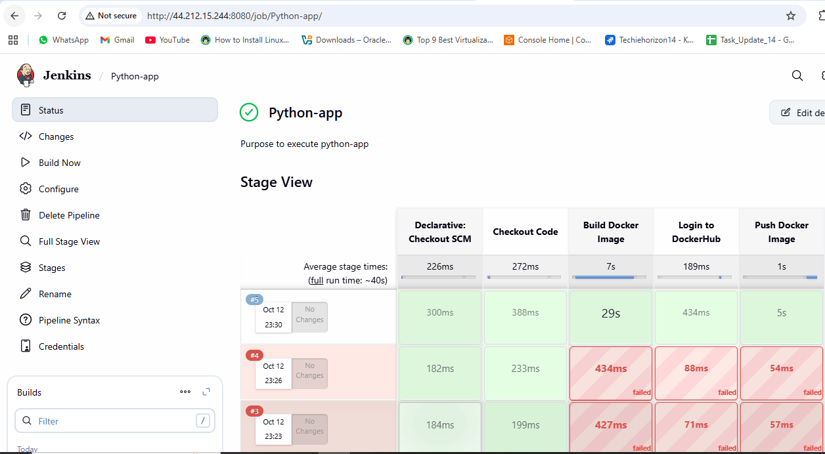
Verify the job in Dockerhub
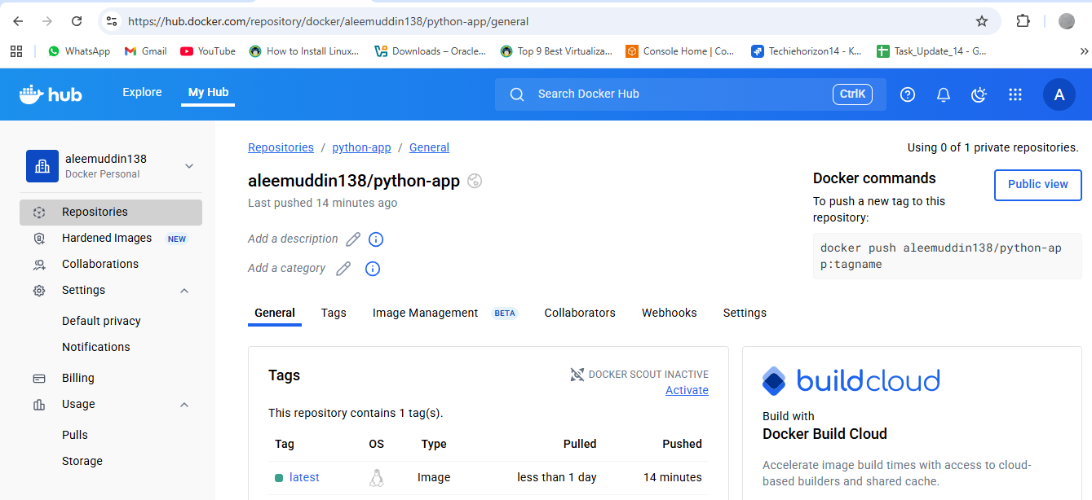

Source Codes: https://github.com/betawins/docker-tasks.git
- From the frontend source code, write a Dockerfile, build a Docker image, run it, and push that image to your Docker registry.
1. Clone the repo
git clone https://github.com/betawins/docker-tasks.git
cd docker-tasks/frontend
2. Write your Dockerfile inside the frontend/ folder
Create a file named Dockerfile:
# Use Nginx to serve static files
FROM nginx:alpine
# Copy all frontend files into Nginx html folder
COPY . /usr/share/nginx/html
# Expose port 80
EXPOSE 80
# Start Nginx
CMD ["nginx", "-g", "daemon off;"]
3. Test locally before Jenkins
Build:
docker build -t < your-dockerhub-username >/frontend-app:latest .
Run:
docker run -d -p 8082:80 --name frontend-test < your-dockerhub-username >/frontend-app:latest
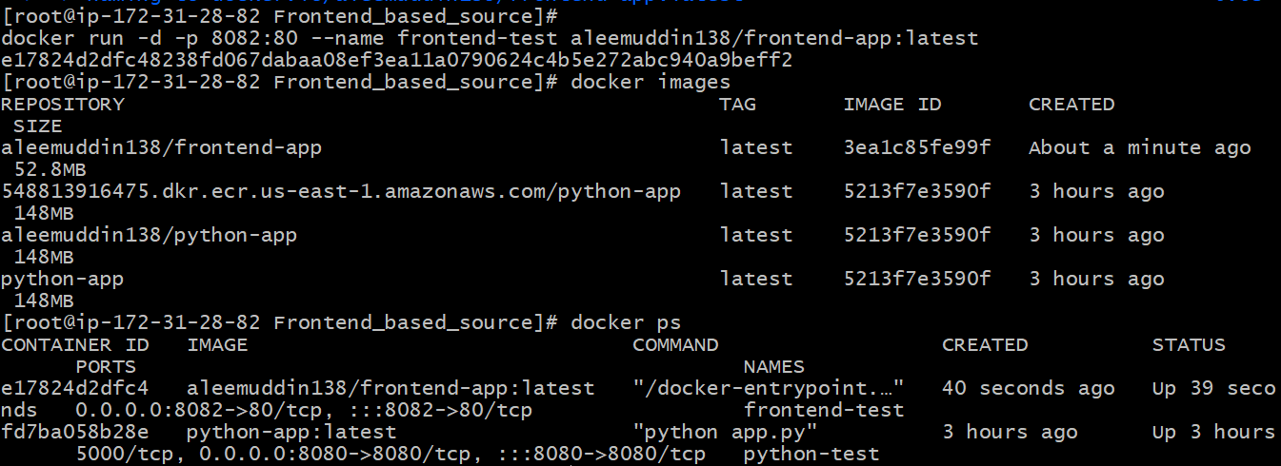
NOW Check in browser:
http://<EC2-Public-IP>:8082
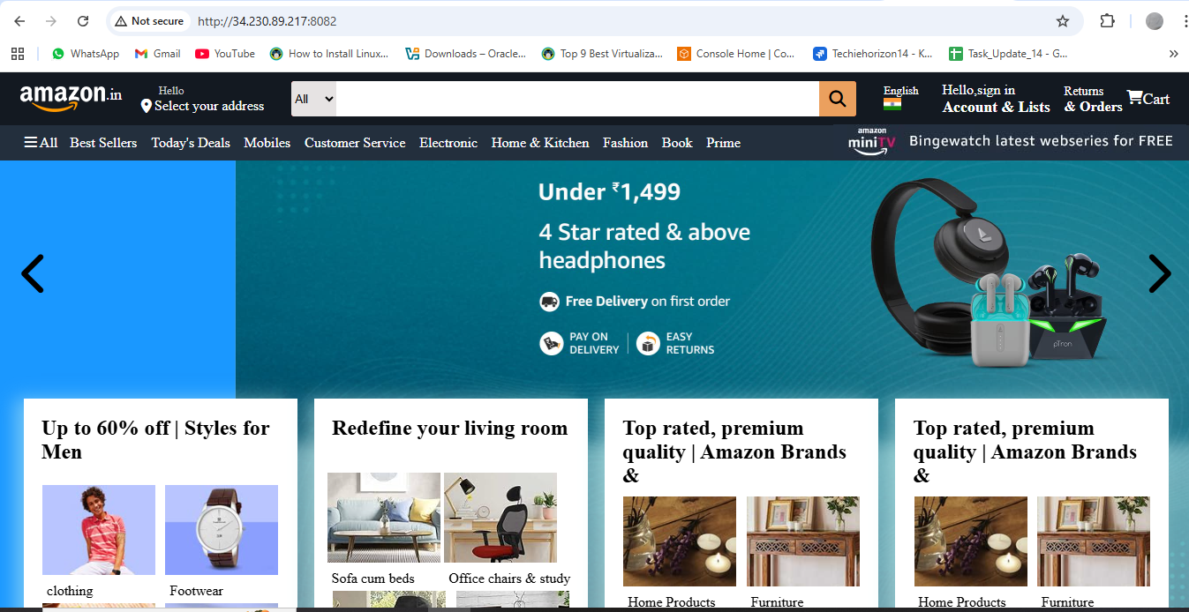

5. Check in docker hub.
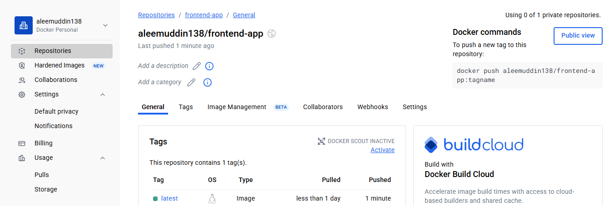

- From the Java-based source code, write a Dockerfile, build, run, and push the image to the Docker registry.
1. Write a Dockerfile inside the Java app folder
For a Maven-based Java app:
# Stage 1: Build the Java app
FROM maven:3.9.3-eclipse-temurin-17 AS build
WORKDIR /app
# Copy Maven config files
COPY pom.xml .
COPY src ./src
# Build the app
RUN mvn clean package -DskipTests
# Stage 2: Run the app
FROM eclipse-temurin:17-jdk-alpine
WORKDIR /app
# Copy the built JAR from the previous stage
COPY --from=build /app/target/*.jar app.jar
EXPOSE 8080
# Run the Java app
ENTRYPOINT ["java","-jar","app.jar"]
2. Build the Docker image
Go to your Java app folder:
docker build -t < your-dockerhub-username>/java-app:latest .
3. Run the Docker container
Map container port 8080 to host port 8083 (to avoid conflicts):
docker run -d -p 8083:8080 --name java-test < your-dockerhub-username >/java-app:latest
Test in browser:
http://<EC2-public-ip>:8083
4. Push image to Docker Hub
docker login -u < your-dockerhub-username >
docker push < your-dockerhub-username >/java-app:latest

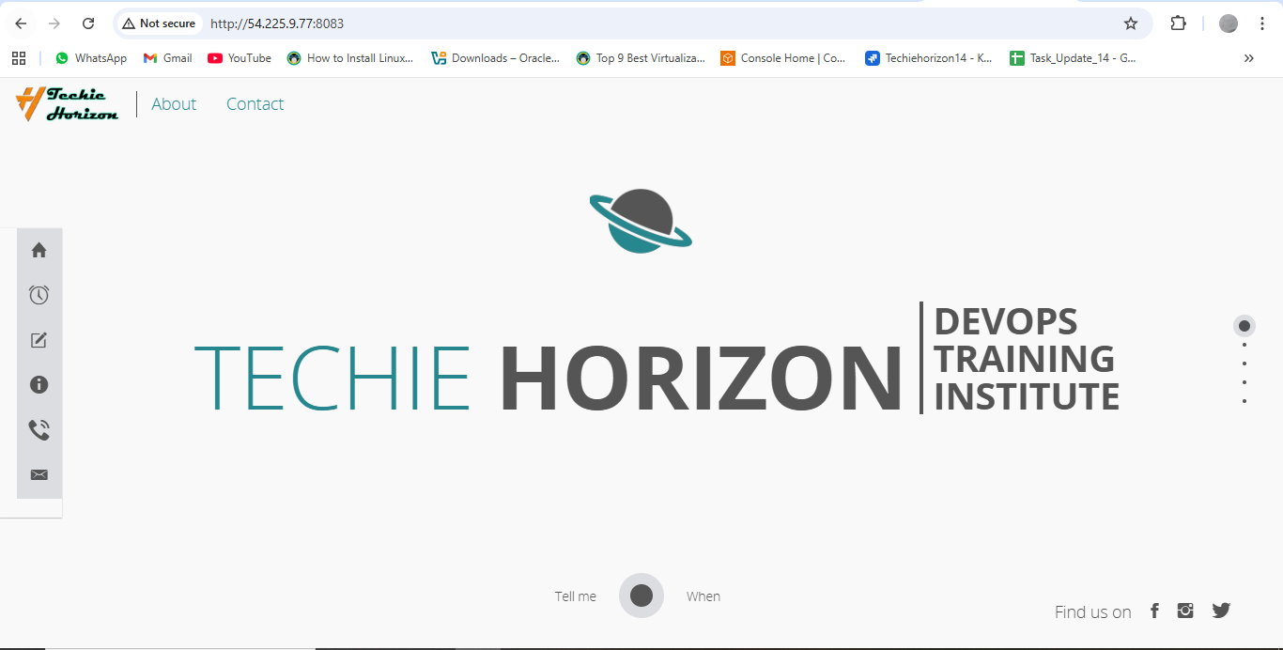
docker ps
docker images
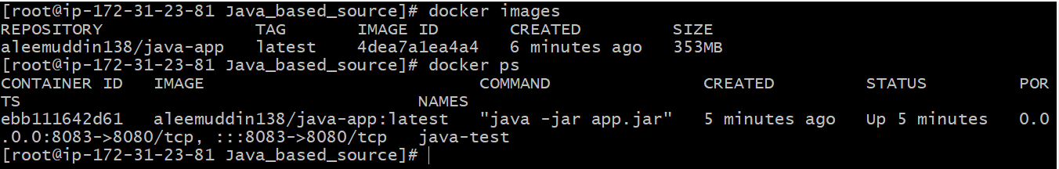
Verify in the docker hub
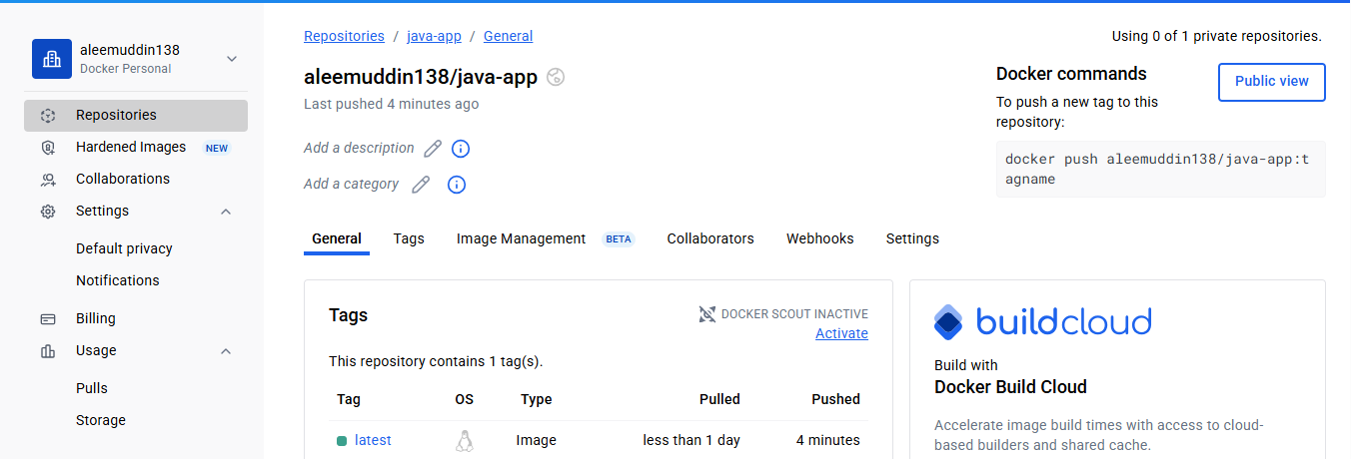

- From the Node.js-based source code, write a Dockerfile, build with tag v1, run, and push it to the Docker registry.
1️⃣ Prepare the Dockerfile
Inside your Node.js/React source folder, create a Dockerfile:
# Stage 1: Build React app
FROM node:18 AS build
WORKDIR /app
COPY package*.json ./
RUN npm install
COPY . .
RUN npm run build
# Stage 2: Serve with Nginx
FROM nginx:alpine
COPY --from=build /app/build /usr/share/nginx/html
EXPOSE 80
CMD ["nginx", "-g", "daemon off;"]
2️⃣ Build Docker image
Run this in the folder containing the Dockerfile:
docker build -t < your-dockerhub-username >/node-app:v1 .
Check that the image is created:
docker images
3️⃣ Remove old container (if exists)
docker rm -f node-app
4️⃣ Run the container
Map host port 8084 to container port 80:
docker run -d -p 8084:80 --name node-app < your-dockerhub-username>/node-app:v1
Verify it’s running:
Open in browser:
http://<EC2-public-IP>:8084

Log in docker if not done.
Tag the image
docker tag < your-dockerhub-username >/node-app:v1 <your-dockerhub-username>/node-app:v1
Push to Docker Hub:
docker push <your-dockerhub-username>/node-app:v1
docker images
docker ps
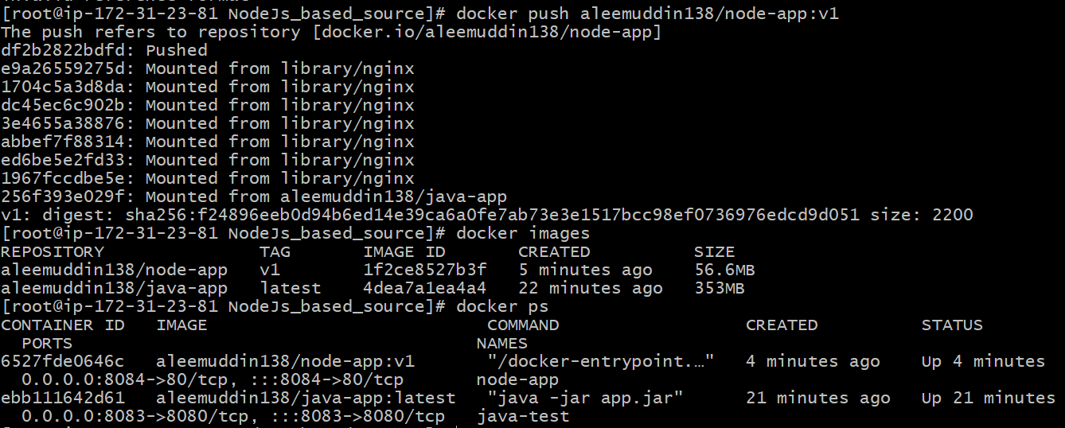
Verify the Docker hub
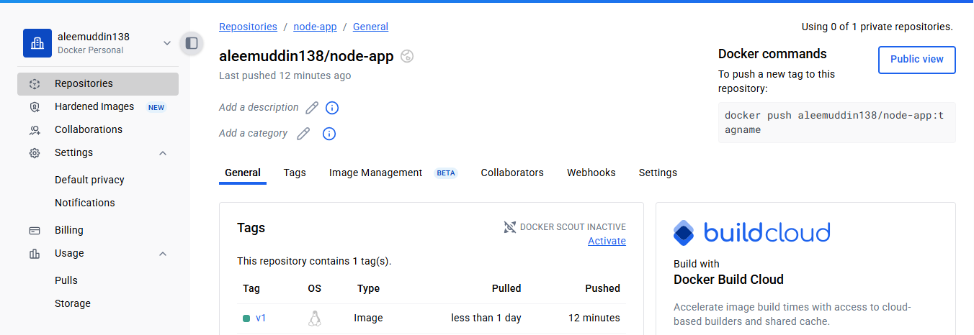

- Write a docker-compose file to set up WordPress with a MySQL database.
Install legacy docker-compose binary:
sudo curl -L "https://github.com/docker/compose/releases/latest/download/docker-compose-$(uname -s)-$(uname -m)" -o /usr/local/bin/docker-compose
sudo chmod +x /usr/local/bin/docker-compose
docker-compose --version
Step 1: Create a folder for your compose project
mkdir wordpress-compose
cd wordpress-compose
Step 2: Create a docker-compose.yml file (edit username and password)
version: '3.8'
services:
db:
image: mysql:8.0
container_name: wordpress-db
restart: always
environment:
MYSQL_ROOT_PASSWORD: rootpassword
MYSQL_DATABASE: wordpress
MYSQL_USER: wpuser
MYSQL_PASSWORD: wppassword
volumes:
- db_data:/var/lib/mysql
wordpress:
image: wordpress:latest
container_name: wordpress-app
depends_on:
- db
ports:
- "8080:80"
restart: always
environment:
WORDPRESS_DB_HOST: db:3306
WORDPRESS_DB_USER: wpuser
WORDPRESS_DB_PASSWORD: wppassword
WORDPRESS_DB_NAME: wordpress
volumes:
- wp_data:/var/www/html
volumes:
db_data:
wp_data:
Step 3: Run Docker Compose
docker-compose up -d
-d runs containers in detached mode.
Docker will pull WordPress and MySQL images if not present.
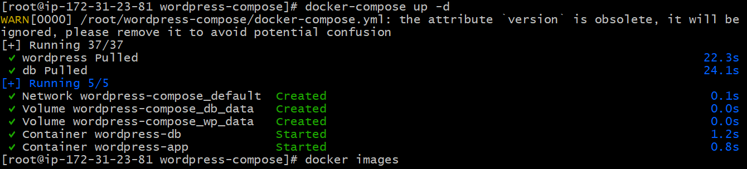
Step 4: Verify running containers
docker ps
docker images
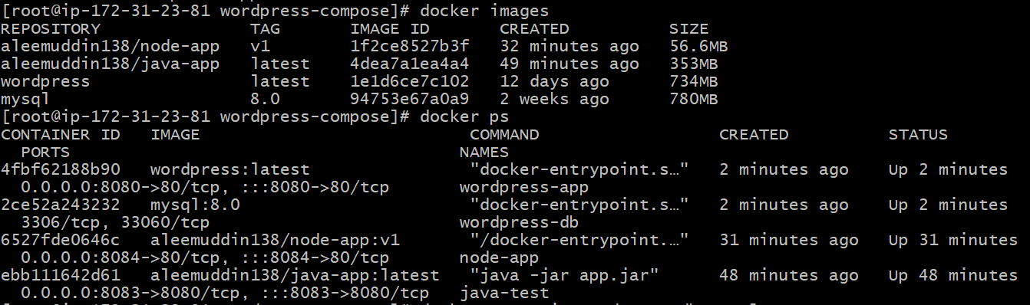
Run mysql
Connect to MySQL inside the container
docker exec -it wordpress-db mysql -u wpuser -p
● Enter the password you set in docker-compose.yml (example: wppassword).
You should see the MySQL prompt:
mysql>
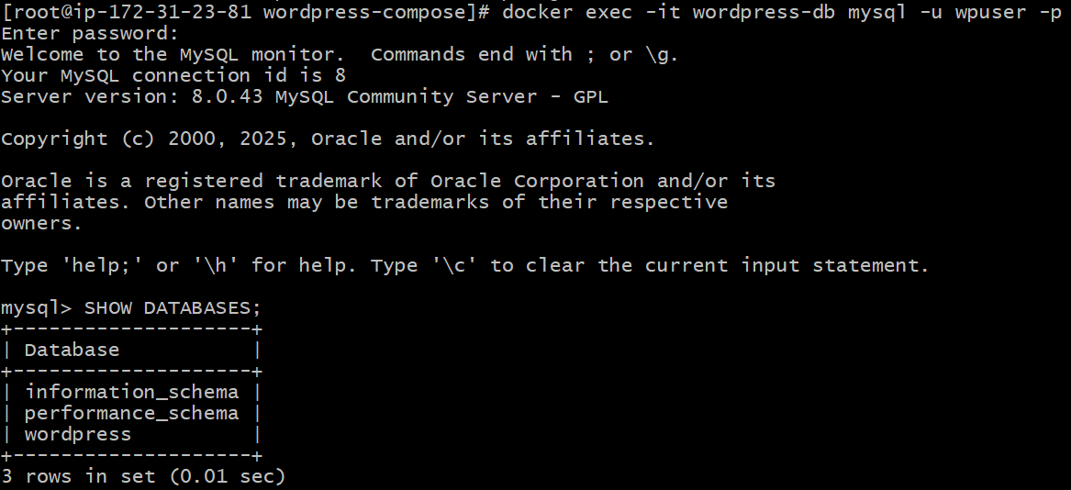
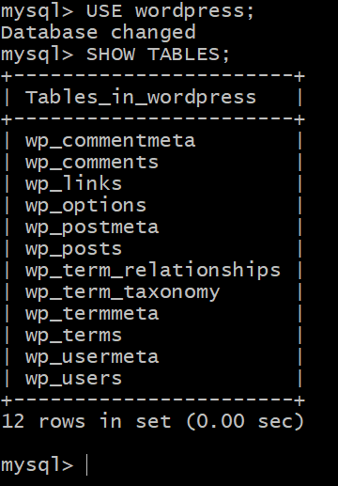
Step 5: Access WordPress
Open in browser:
http://<EC2-public-IP>:8080
You’ll see the WordPress setup screen. Complete the setup using the DB credentials:
● DB Name: wordpress
● DB User: wpuser
● DB Password: wppassword
● DB Host: db:3306
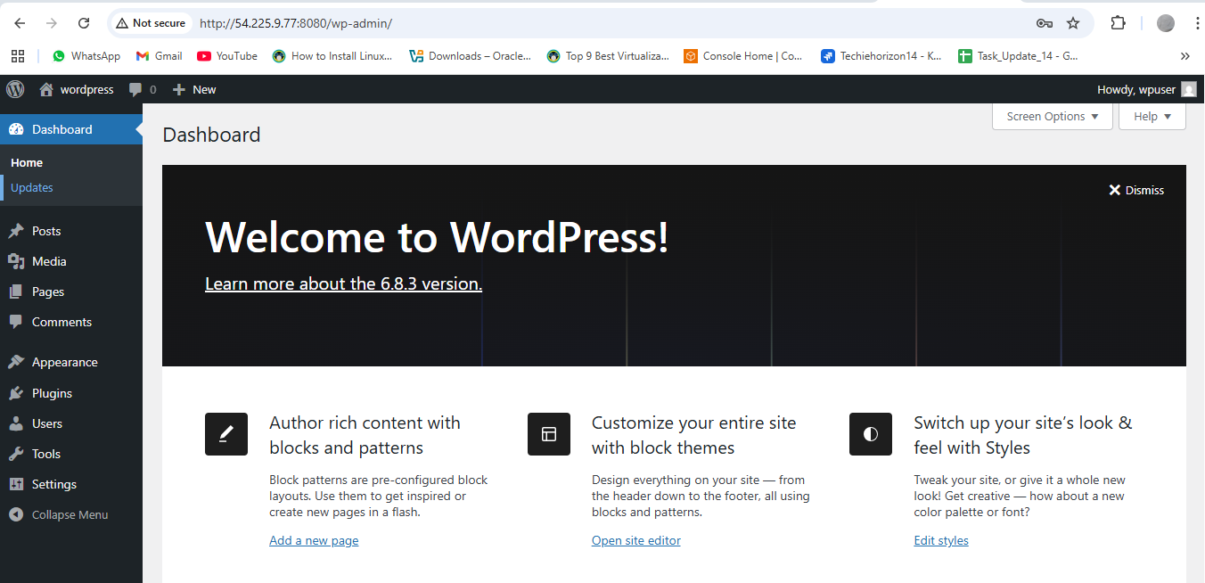
Sample Things to Try
a) Add a Post
1. Go to Posts → Add New
2. Enter a title and content
3. Click Publish
4. Check your homepage, the post should appear.
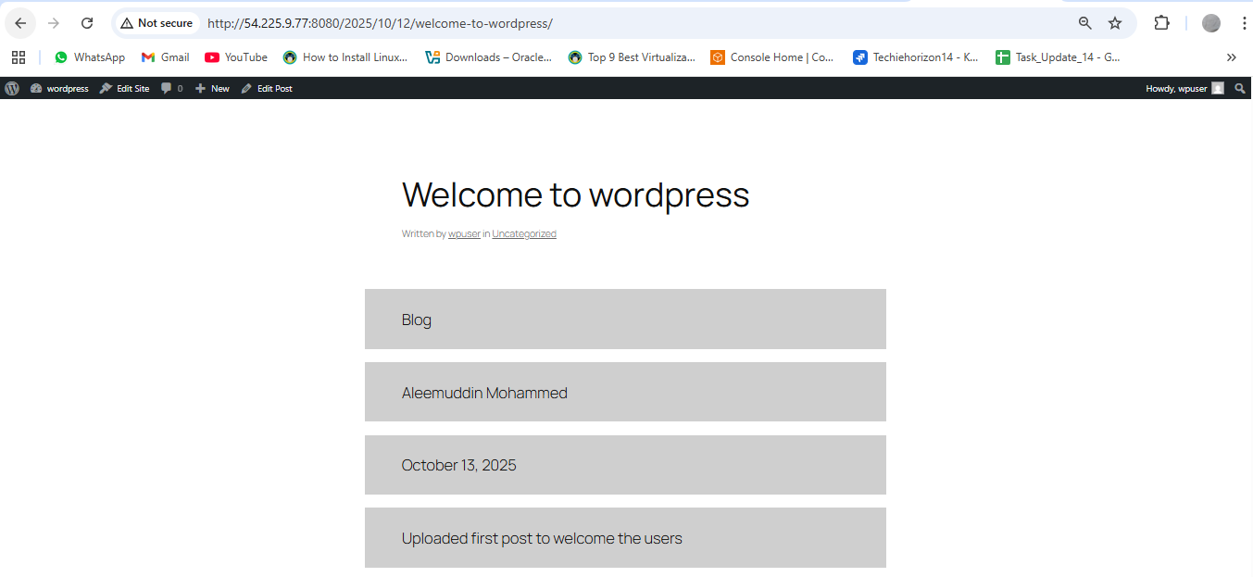

1️⃣ What is WordPress?
● WordPress is a content management system (CMS).
● It allows you to create and manage websites without coding everything from scratch.
● It’s written in PHP and uses MySQL for its database.
● Open-source and widely used for blogs, business websites, e-commerce, and portfolios.
________________________________________
2️⃣ Key Features
1. Posts & Pages – Write articles (posts) or create static pages (About, Contact).
2. Themes – Pre-designed templates to change the look of your website easily.
3. Plugins – Add extra features like contact forms, SEO tools, or galleries.
4. Users & Roles – Admin, Editor, Author, Subscriber, etc., to manage permissions.
5. Media Management – Upload images, videos, and documents easily.
________________________________________
3️⃣ How it works with Docker in your setup
● You have two containers:
1. MySQL container → Stores all website data: posts, users, settings.
2. WordPress container → Runs the website itself and connects to MySQL.
● When you open http://<EC2-IP>:8080, WordPress fetches content from MySQL and shows your website.
________________________________________
4️⃣ Real-life analogy
Think of WordPress as a ready-to-use kitchen:
● Ingredients = your posts, images, plugins, and pages
● Kitchen tools = themes, plugins, admin dashboard
● Result = a fully functioning website without building everything from scratch
______________________________________
5️⃣ What you can do now
●Write your first post or page.
● Change the theme to customize your website.
● Install a plugin like a contact form.
● Check how all the content is stored in MySQL.

